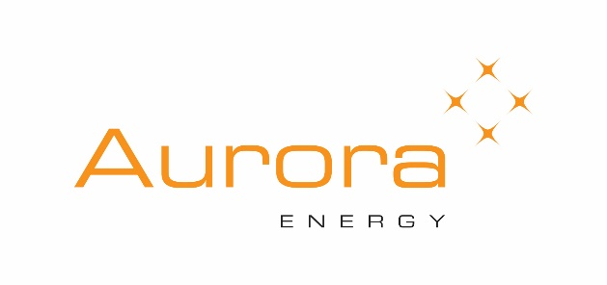
Aurora Energy Otago Science & Technology Fair –
Dunedin

ATTENTION
TEACHER IN CHARGE OF SCIENCE FAIR

Please send your School Entry to: Steven Sexton
College of Education
PO Box 56, Dunedin
Ph 03 479 4285
Email: steven.sexton@otago.ac.nz

BEFORE FRIDAY 28th July 3:00 PM

Please note that entry forms for participants will be emailed in advance of judging day.
…………………………………………………………………………….

Otago Science Teacher Association Membership (if applicable)
Membership Number: ______________

Science Fair Entry 2023

School
Teacher in charge__________________________________________
Email address _______________________________________ Phone

Number of entries requested:
Year 7
Year 8
Years 9 & 10
Years 11,12 & 13

